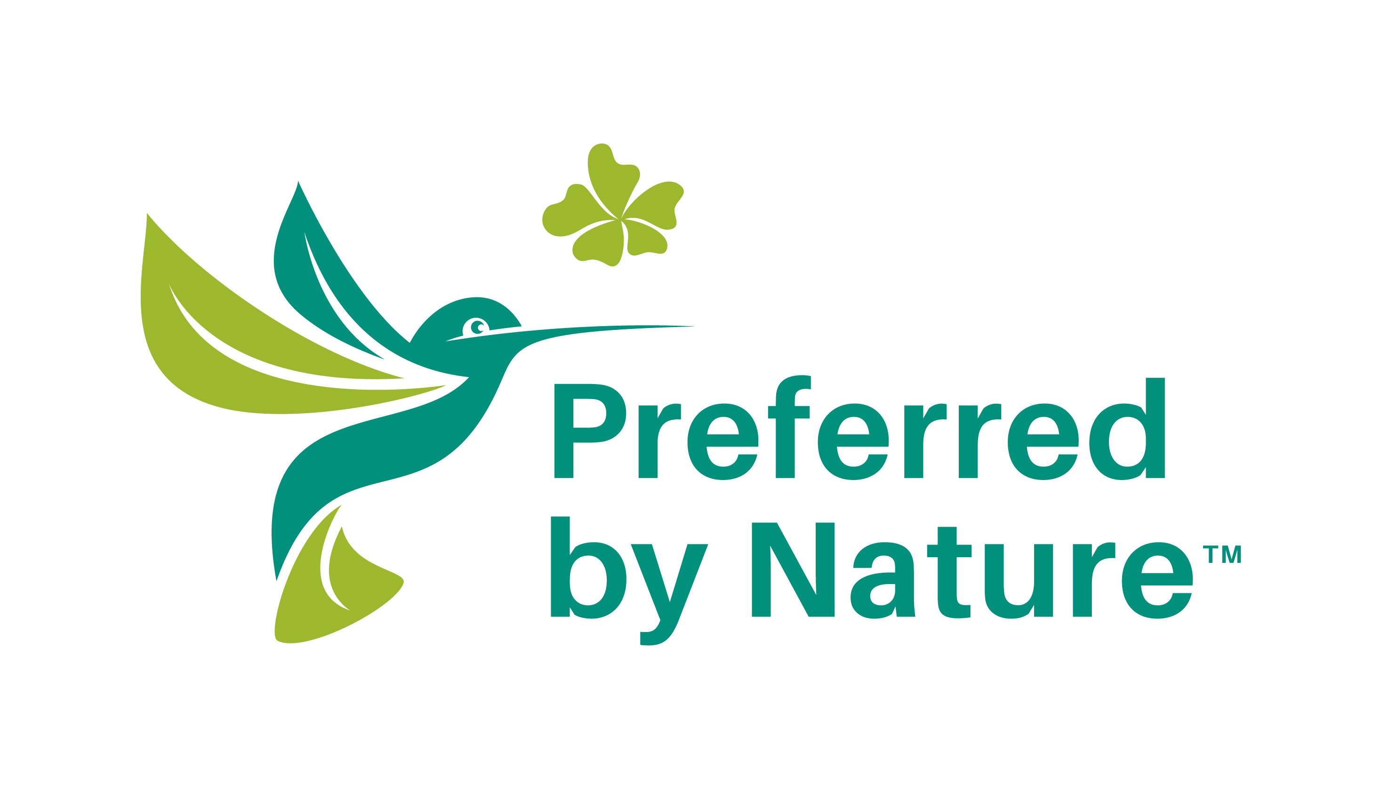
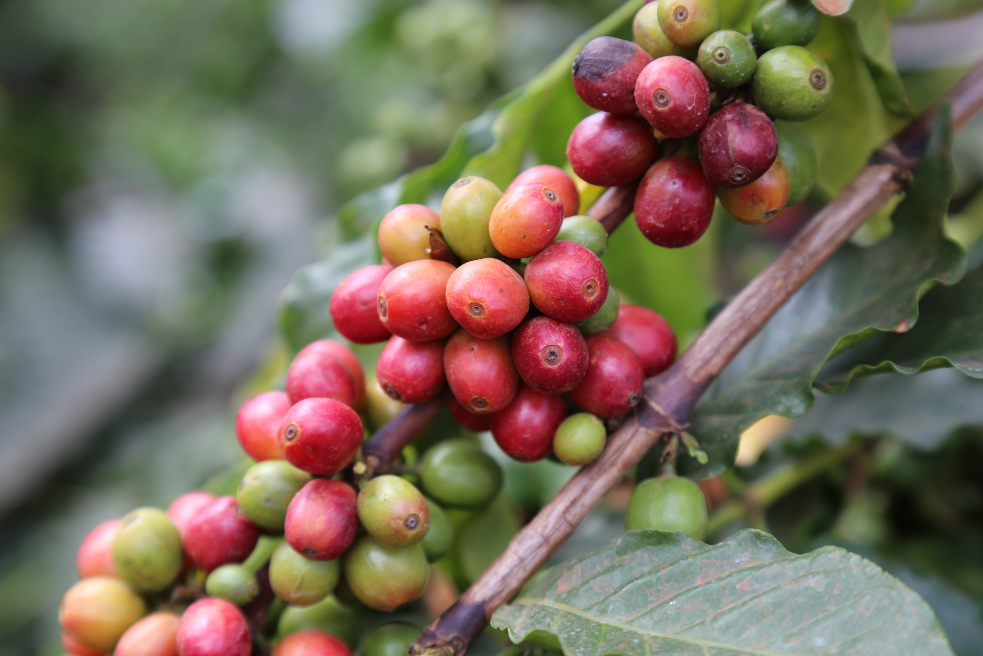
September 2020
Guide

Sample Rainforest Alliance
Chain of Custody procedures

How to use this document
You may use this document for inspiration on how to develop and structure your own company-specific Rainforest Alliance Chain of Custody Certification (RA CoC) procedures. Please be aware that this is a generic, fictional example and that you need to develop your own procedures that are specifically tailored to your company set-up and the scope of your certification.
Please note that the following elements are used throughout the document:
- References to a specific point in the applicable RA COC Standard are given in parentheses. These will help you to go directly to the relevant part of the SCC standard and find out why certain sections or elements have been included in the procedures.
- Text in green is not part of the sample procedures, but contains explanatory notes, information and links that can help you understand the standards and RA COC requirements.
IMPORTANT
This document is provided by Preferred by Nature (formerly known as NEPCon) as a generic example of RA CoC procedures. The company presented in these procedures is fictional and the specific system details are provided merely as examples.
These sample procedures have been designed to help you to comply with the Rainforest Alliance Chain of Custody Standard by providing an example of how SCC procedures may be structured.
This is a support tool that you may use voluntarily as a basis for developing your own company-specific procedures. It cannot be applied directly. You always need to develop and tailor your own procedures.
Using this document is not mandatory for achieving certification, and does not imply any guarantee or assurance regarding the conformance level of your actual company procedures.
Although we have made an effort to cover all Standard requirements, we do not provide any guarantee as to the completeness of these procedures.
Used Rainforest Alliance documents:
- Rainforest Alliance Chain of Custody Certification (Version 3, July 2015)
- Traceability Guidelines (October 2018)
- Mass Balance Guidelines (October 2018)
- Requirements and Guidelines for Use of the Rainforest Alliance Trademarks (July 2016)

Preferred by Nature has adopted an “Open Source” policy to share what we develop to advance sustainability. This work is published under the Creative Commons Attribution Share-Alike 3.0 license. Permission is hereby granted, free of charge, to any person obtaining a copy of this document, to deal in the document without restriction, including without limitation the rights to use, copy, modify, merge, publish, and/or distribute copies of the document, subject to the following conditions:
- The above copyright notice and this permission notice shall be included in all copies or substantial portions of the document. We would appreciate receiving a copy of any modified version.
- You must credit Preferred by Nature and include a visible link to our website www.preferredbynature.org.
Contents

1. Introduction to the procedures manual 4
2. Company background 4
3. Responsibilities 4
4. Training 6
5. Records 6
6. Procedure for handling complaints 7
7. Internal audit 7
8. Purchasing and goods in 8
9. Incoming materials & stocks 8
10. Material handling and supply chain model implementation 9
11. Volume control 10
12. Registration of transactions 12
13. Sales and delivery 12
14. Outsourcing 13
15. RA COC product list 13
16. Claims 13
17. Annual external RA COC audit 14
Annex 1: Documentation for training of staff 15
Annex 2: Volume summary and Supplier List 16
Annex 3: RA COC certified product list 17
Annex 4: RA CoC outsourcing agreement 18
Annex 5: List of subcontractors 20
Annex 6: Internal audit report 21
Annex 7: Self-declaration 22

RA COC procedures for [Sustainable Produce Ltd]

- Introduction to the procedures’ manual
In order to ensure our fulfilment of all applicable RA COC requirements, [Sustainable Produce Ltd] has compiled this Rainforest Alliance Chain of Custody Certification (RA CoC) manual. The manual is based on the Rainforest Alliance CoC Standard Version 3 (July 2015) and it addresses all applicable requirements of this standard. The Production Manager is responsible for the maintenance and correct implementation of this manual (RA COC 1.1 c).
This manual is prepared to help our employees to:
- control the flow of materials throughout the reception, processing, packing and shipping processes so that all applicable RA COC requirements are met; and
- ensure that we meet the requirements of Rainforest Alliance CoC Standard Version 3 (July 2015)
- ensure that preservation of the certified material is covered by internal procedures, in accordance with the affirmation (RA COC 2.1).

- Company background
[Sustainable Produce Ltd] was established in 2001 and is a medium-sized confectionary production company. The total turnover of the company in 2017 was 2.4 million EUR. We employ approximately 50 full-time staff.
Our company facilities include raw material storage, two production lines and final product storage facilities. More information about the company is available in our latest annual report.

- Responsibilities
The person with overall responsibility and authority for compliance with all applicable RA COC requirements is the Production Manager (RA CoC 1.1c). The Production Manager is also responsible for implementing and maintaining up-to-date documented procedures covering the certification requirements applicable to [Sustainable Produce Ltd]’s certificate scope.
Responsibilities for separate areas are specified in each part of the procedures. Responsibilities are also summarised in the following table:
Table 1. Responsibilities of staff
Area | Responsible | Area | Responsible
Training and staff awareness | Production Manager | Product labelling  Production of sales waybills | Production team leader
Supplier validation and material sourcing  Purchasing of raw material  Verification of purchase documents  Incoming transaction certificates in Marketplace | Purchase Manager | Promotional and off-product use of trademarks  Preparation of sales contracts  Asking for RA Trademark approval in Marketplace | Sales Manager
Material reception | Production team leader | Annual volume summary | Bookkeeper
Production and segregation in processing  Product group list | Production Manager | Preparation of sales invoices and shipping documentation  Outgoing transaction certificates in Marketplace | Bookkeeper
Volume control and conversion factors | Production Manager | Outsourcing | Production Manager
Occupational health and safety | Production Manager | Complaints procedure  Transaction registration | Sales assistant
Note: The overall responsible person is responsible for any areas not specified in this table.

- Training
In our company, RA COC related training is relevant for all full-time employees, carrying out tasks critical to effective implementation of the supply chain requirements. Training covering the full CoC system and based on this manual is provided to all staff. Initial training is conducted before initial assessment and additional brief training is conducted once per year, when the results of the external RA COC audit are available. New staff shall be personally introduced to this manual before they start work at [Sustainable Produce Ltd] (RA CoC 1.2).
Training topics are specific and relevant to the tasks performed to effectively implement the CoC system (RA CoC 1.2).
The Production Manager is responsible for implementing this training procedure.
For each training session the date of the training, the list of participants, and a brief overview of the topics covered will be documented. Training of new staff is documented by the employee’s signature and the date of training on a separate staff instruction sheet. (RA CoC 1.6).

- Records
To enable us to effectively monitor the RA COC system, we maintain records covering all steps and elements of our RA COC system (RA CoC 1.6). Records can be available digitally or on paper in [Sustainable Produce Ltd]. The minimum maintenance time for all records is three (3) years (RA CoC 1.6).
Table 2. Summary of the records maintained by Company Ltd related to our RA COC certificate scope
Record name | Location
Raw material orders | Emails saved on server, in the folder ‘Production’
Purchase waybill, purchase invoice | Digitally stored in the accounting programme
List of suppliers | Extracted from the accounting programme
Volume information of RA input in the end products, acceptable levels of contamination including conversion factors (RA COC 2.5) | Extractable from the accounting programme
Up-to-date record of volume purchased (input), stock and claimed (output) (RA COC 2.4) | Extractable from the accounting programme
Production orders | Excel files stored on the server, in the folder ‘Production’
Production work sheets | Entered into Excel based on paper sheets; Excel files are saved on the server, in the folder ‘Production’
Stock inventory | Excel files stored on the server, in the folder ‘Inventory’
Sales invoice | Digitally stored in the accounting programme
Sales waybill | Digitally stored in the accounting programme
Product label types used on products | Sample label designs stored on the server, in the folder ‘Production’
Occupational health and safety | Hard copy stored in the Production Manager’s office and also presented on the message board
Specific RA CoC documents
This document | Digitally stored on the server, in the folder ‘RA COC’
RA CoC training records | Annexed to this document. Annex 1.
RA CoC personnel training instruction sheet | Hard copy stored in the Production Manager’s office
Outsourcing contract | Stored on the server, in the folder ‘Contracts’. Annex 4.

- Procedure for handling complaints
[Sustainable Produce Ltd] ensures that complaints received regarding our conformity to the requirements applicable to the scope of our RA CoC certificate are adequately considered, including the following (RA CoC 1.7):
- acknowledge receipt of the complaint to the complainant;
- investigate the complaint and specify our proposed actions in response to the complaint;
- take appropriate actions with respect to complaints and any deficiencies found in processes that affect conformity to the certification requirements;
- notify the complainant when the complaint is considered to be successfully addressed and closed.
We register the complaints in our ERP-system and keep them on record (RA CoC 1.6).
- Internal audit
The Production Manager is responsible for conducting an annual internal audit of the RA COC system to see whether we comply with the requirements in the RA CoC Standard. We also check whether we effectively implement and maintain the requirements within our organisation (RA CoC 1.4). We have an internal audit plan in which we schedule the RA CoC to take place in February.
At a minimum, the following details must be audited:
- Sampling of incoming delivery notes and invoices since last internal/external audit – check for the RA claim or (if required by RA) if all Transaction Certificates are in place (RA CoC 2.3, Traceability Guidelines)
- Sampling of outgoing delivery notes and invoices since last internal/external audit – check for the RA claim or (if required by RA) if all Transaction Certificates are in place (RA CoC 2.3, Traceability Guidelines)
- Interviews of staff involved in the RA CoC system, ensuring that all relevant staff have knowledge of and understand the procedures relevant to their area of responsibility
A summary of the internal audit is prepared (see Annex 4), including details such as:
- Internal auditor’s name
- Date of the audit
- Names and functions of staff interviewed
- Conclusion – including a description of Non-Conformity Reports (NCRs) and observations
- List of corrective actions implemented to address NCRs
- Management signature
- Purchasing and goods in
The Purchase Manager is responsible for purchasing of raw material, for verifying the validity and scope of the supplier’s RA CoC certificate, and for verifying purchase documents (RA COC 2.6). A Transaction Certificate is required for the crops banana, cocoa, coconut, coffee, orange juice products, palm oil and tea.
[Sustainable Produce Ltd] purchases material with the following claims for its RA COC production (see also Annex 4a and 4b):
RA SG (Segregated)
RA MB (Mass Balance)

Raw material is ordered based on the estimated need of material, which can be extracted from sales contracts. The Sales Manager, who prepares sales contracts in Excel, will mark ‘RA CoC certified’ in the Comments field if the buyer wants the material to be RA CoC certified.
The Purchase Manager is responsible for preparing purchase orders for raw material. If certified material is needed, the following statement is marked in the purchase order: ‘Ordered material must be RA COC SG or MB.
Before preparing the purchase order – and, in addition, on a regular basis every third month – the Purchase Manager must confirm that the supplier has a valid RA COC certificate. This is done via the RA Certificate database.
- Incoming materials & stocks
The [Person X] ensures that Transaction Certificates were issued and sent by the suppliers for each delivery (more information in section 12).
The Production team leader on duty is responsible for receiving incoming material and checking appropriate information on the associated delivery documentation including purchase waybills.
The Production Assistant is responsible for entering the correct volumes in the accounting programme and for checking that the invoices match the delivery documents.
The materials are delivered by trucks to our warehouse where the Production Team Leader receives it. When material is delivered as certified, the Production Team Leader shall check the following (RA CoC 2.6):
- The name and address of the buyer
- The name and address of the seller
- The loading or shipment / delivery date
- The date on which the documents were issued
- A description of the product, including the applicable supply chain system (Segregated or Mass Balance, or SG or MB) and the claim.
- The quantities and material type of the supplied material corresponds to the raw material purchase order and to the information on the delivery documentation.
- Any related transport documentation
- A unique identification number (invoice number)
If it is clear that the material is certified and corresponds with the ordered material – i.e. it meets the criteria listed above - the Production Team Leader will see the material unloaded to the appropriate place in the warehouse and they will attach a label with the letters ‘RA COC’ so that certified material is clearly distinguishable and kept separate from other materials (RA COC 2.2).
If any of the conditions mentioned in the points above are not fulfilled, the material cannot be accepted as certified and is not labelled with internal RA COC labels.
At the end of each workday, the Production Team Leader takes the delivery documentation including purchase waybills to the office, where the Production Assistant registers the received material in the accounting programme so that it is added to the existing stock. When we receive an invoice, the Production Assistant shall check that the invoice contains the information shown above. If any information is missing, the material cannot be used as certified and corresponding corrections need to be made physically on material pallets and in the accounting programme.
- Material handling and supply chain model implementation
[Sustainable Produce Ltd] uses the Segregated system to produce RA COC SG certified products, and the Mass Balance method to produce RA COC MB-certified products. We keep all materials to be used for RA COC SG production physically separate from non-certified materials throughout reception, processing, packing and shipping.

The Production Manager, who prepares production orders, is responsible for ensuring that these documents are clearly marked ‘RA COC’, if the material has been ordered and must be produced as RA COC certified.

It is the responsibility of the Production Team Leader to ensure that only certified materials are used for orders of certified products.

At the end of each workday, the volumes of raw material used for production are added up. The Production Manager deducts these volumes from the raw material stock in the accounting programme.

Segregated

Certified material is always processed separately (in separate spaces or at separate times) from non-certified material (RA CoC 2.2).

After the first processing stage, a green tracking label with the letters ‘RA COC’ is attached. This ensures that RA COC certified material is always clearly distinguishable during production.

It is the responsibility of all staff to ensure that no non-certified material is mixed with certified material, i.e. for orders where green tracking labels are used. Note that it is acceptable to use RA COC certified material to produce non-certified products.

It is permissible to mix together RA COC SG from different sources.

When a product is ready, the tracking label is taken by the relevant production worker to the Production Manager, who enters the final product details in the ‘final product stock’ in the accounting programme (RA COC 2.4).
Mass Balance
[Sustainable Produce Ltd] also has the option to use the Mass Balance system. This allows us to mix RA COC and non-RA COC certified products provided that overall site quantities are controlled (RA CoC Mass Balance Guidance). We will reconciliate the quantity of the RA COC certified products bought and the quantity of RA COC certified products sold. This includes control of purchases and sales of RA COC certified products which shall be independently certified). If we choose this option, there are no requirements for separate storage, transportation or controls in the production process (RA CoC Mass Balance Guidance). There are however rules for Mass Balance accounting, as described in the next chapter.
- Volume control
The Production Manager assumes overall responsibility for volume control. The Bookkeeper is responsible for preparing a correct annual volume summary over a period of twelve months (RA COC 2.4).
The Production Manager is responsible for the following:
- Received volumes, based on delivery documentation, are recorded under ‘raw material stock’ in the accounting programme.
- Volumes used for production are recorded daily by the Production Manager based on the production work sheets. These volumes are subtracted from the raw material stock in the programme.
- When a product is ready, final product details are entered in the ‘final product stock’ in the accounting programme, based on production work sheets.
- Updating the conversion factor calculations, at least once every quarter, based on the volume records of the past six (6) months. The conversion factor shall be calculated in the following manner: conversion factor = final products produced during the month / raw materials used for production. We calculate the conversion factor for the total production process (RA COC 2.5).
The Bookkeeper is in charge of the following:
- After material has been loaded for delivery to the buyer and the sales invoice has been issued, the product volumes are subtracted from final product stock.
- Purchased and sold material can be filtered out in the accounting programme based on seller/buyer, RA COC certified / non-certified status of material, and/or any time period.
For all certified material, [Sustainable Produce Ltd] uses separate accounting codes starting with the letter ‘RA’ or ‘RA SG’ for RA COC Segregated certified material or MB for RA COC Mass Balance certified material. In this way it is always possible to separate and identify certified material from non-certified material in the accounting programme.
Volumes of purchased RA COC raw material can be extracted from the programme at any time by filtering for the letter SG or MB in the accounting code.
Each January, the Bookkeeper shall prepare an annual volume summary relating to the past 12 months, where the following volumes are summarised for each calendar year and shown for each supplier or buyer: volumes received; volumes used for production; remaining raw material volumes in stock; products sold; final products still in stock. The summary is sent to the Production Manager, who sends this information to our Certification Body prior to the audit (RA CoC 2.4)
Mass Balance
If we choose to mix RA COC certified with non-certified material, we can also choose to do Mass Balance Accounting. Mass Balance is only allowed for Cocoa, Coconut Oil, Palm Oil, Orange Juice (Mass Balance Guidance, October 2018).
All sales and shipment transactions of mass balance materials or products claimed as Rainforest Alliance Certified must be reported to the Rainforest Alliance using our online system, Marketplace 2.0. At minimum, all sales conducted during a calendar quarter must be registered in Marketplace 2.0 within 30 days of the end of that quarter.
Mass balance credits are valid for a maximum of three years. If sales exceed purchases, these must be covered with sufficient purchases of certified inputs by the end of the quarter in order to issue Transaction Certificates (TCs) for that quarter. Unused credits can be carried over and recorded in the material accounting system for the following inventory period.
When using mass balance, transaction certificates (TCs) for purchases of the certified ingredients should reflect the recipe of the product. For example, if the formulation for a chocolate product is 30 percent cocoa butter and 70 percent cocoa powder, TCs should be purchased for these certified ingredients in the same proportions. It is not possible to convert or substitute TCs unless this reflects the processing that has taken place or could take place e.g. cocoa powder TCs cannot be converted to cocoa butter TCs, but cocoa bean TCs may be converted to cocoa powder or butter using the standard conversion ratios. Similarly, orange juice soluble solids can be converted to Frozen Concentrate Orange Juice (FCOJ) or Not From Con-centrate (NFC) products, but once there is a TC for NFC then that volume can no longer be converted to FCOJ solids but must be used for NFC products only.
Origin matching for materials or products is only required if the seller wishes to make a claim regarding the country of origin of that product on pack or in sales, marketing, or promotional materials. For example, if a chocolate bar claims to be a blend of cocoa mass from Côte d’Ivoire and Ecuador then the operator must buy certified cocoa with TCs from producers in these origin countries in approximately (within 10 percent margin of error) the same proportions as in the recipe for the product.
If no origin claim is made, the source country on the Transaction Certificates may differ from the physical origin of the product as a result of mixing. The country stated on the TC indicates the country where a volume of ingredient equivalent to the volume used to produce the product was purchased from Rainforest Alliance Certified farms.
Avoiding Double Counting for Multi-Certified Materials
If a batch of certified material is purchased from a farm that has more than one sustainability certification (e.g. Rainforest Alliance and Fairtrade), then the equivalent volume of material can be sold forward with both certifications attached to the batch. However, the two certifications may not be separated and applied to two separate batches of material, each equivalent in volume to the original purchase, as this would be considered double accounting. Volumes entered in Marketplace 2.0 as Rainforest Alliance Credits and sold under an alternative scheme must be recorded in Marketplace as “Sold as non RAC.”
For example, if an operator has purchased 100 MT of cocoa powder made from beans grown on a farm that has both Rainforest Alliance and Fairtrade certification, the company cannot sell forward 100 MT of Rainforest Alliance Certified cocoa powder and 100 MT of Fairtrade certified cocoa powder. Instead, the total volume of cocoa powder that can be sold forward as certified (Rainforest Alliance and/or Fairtrade) from that batch must not exceed 100 MT. The Rainforest Alliance is working closely with other certifications to avoid double counting of certified materials, and this will be carefully checked during CoC audits.
Conversion Ratios
If a user wishes to convert mass balance credits to allow them to be used for further processed materials (for example from cocoa beans to liquor, or from cocoa liquor to powder and butter) then they must use the conversion ratios set out per crop below. It is not possible for credits to be converted backwards (e.g. from cocoa liquor to beans) or in any other manner inconsistent with actual processing conversions. Details of the specific ratios per crop are provided in the appendices to the Mass Balance Guidance. In the case of orange juice products, the original yield at first extraction will determine the number of soluble solids available for the different products, NFC or FCOJ. Once these solids are converted via a TC to FCOJ for example, then the mass balance credits going forward will only be valid for FCOJ products and cannot be converted to NFC.
- Registration of transactions
Since [Sustainable Produce Ltd] is using banana/cocoa/coconut oil/coffee/orange juice products/palm oil / tea, we need to request and issue transaction certificates (RA CoC 2.3, Traceability Guidelines) Our Sales Assistant is responsible for registering the transactions in marketplace.ra.org.
- Sales and delivery
All products that we sell as certified are sold with the appropriate claim (RA COC 2.7, RA CoC Mass Balance Guidance).
When material is loaded onto the truck to be delivered to the buyer, the Production Team Leader prepares a sales waybill. Transport documents covering certified products include [Sustainable Produce Ltd]’s RA COC certification code and the appropriate claim:
- For the RA COC SG:
RA X% - including information about the certified percentage when the unlabelled product contains less than 100% certified content (when applicable).
- For the RA COC MB:
RA MB X% - reference to RA mass balance material and to the volumes that is less than 100 percent of the total shipment volumes. The total volume amount as certified shall be indicated on all associated documentation.
This information is automatically generated on the sales invoice via the accounting programme when the correct type of certified product is selected.
A copy of the sales waybill is given to the Bookkeeper, who prepares a sales invoice according to the waybill. [Sustainable Produce Ltd] invoices covering certified material include the following information:
- Name and contact details of [Sustainable Produce Ltd] – this information is permanently included in the invoice template.
- Name and address of the customer – the specific buyer is selected from the accounting programme.
- Date when the invoice was issued – this is entered by the Bookkeeper.
- Description of the product, including the applicable supply chain model and indicate the percentage of the certified content – the same product code is selected as on the sales waybill.
- Quantity of the products sold – entered by the Bookkeeper based on the sales waybill.
- Information regarding correct claim is tied to the product and the correct claim appears automatically when specific certified product types are selected from the accounting programme.
Each sales waybill and invoice may cover only exclusively certified or exclusively non-certified material. If both types of material are shipped to a customer, separate sales documents are prepared for certified and non-certified material. Material is always identifiable based on RA COC and pallet numbers shown on the waybill.
- Outsourcing
The Production Manager is in charge of our relations with the subcontractors. In case we need to outsource activities to independent third parties (e.g. subcontractors for storage, transport or other outsourced activities), we ensure that our subcontractor complies with the requirements of the RA COC Supply Chain Certification Standard and we have a binding outsourcing agreement in place (RA COC 1.5).
We record the names and contact details of all contractors used for the processing or physical handling of RA COC certified Agg palm products, see Annex 5 (RA COC 1.5).
- RA COC product list
We have prepared a RA COC product list that describes which products we can produce as certified and specifies what products our certificate covers. All products that we sell as RA COC certified are sold with the claim appropriate claim (see point 13), see Annex 3.
The Production Manager is responsible for keeping the RA COC product lists up-to-date.
- Claims
[Sustainable Produce Ltd] uses RA COC trademarks on product labels, and they may also be used for promotion of certified materials. The person responsible for the use of RA COC trademarks is the Sales Manager (RA COC 1.1c). We have a signed license agreement with Rainforest Alliance in place (RA CoC 3.1)
Before using any RA COC trademark, we will prepare a project in accordance with Requirements and Guidelines for Use of the Rainforest Alliance Trademarks (July 2016) and upload them in Marketplace to get approval from RA before we use the design. During the external audit, the Certification Body’s auditor will evaluate this correspondence with RA. (RA CoC 3.2).
For on-product labelling, the responsible person shall ensure that the RA COC Seal meets the minimum percentage of certified content (RA CoC 3.3).
- Annual external RA COC audit
Prior to the annual external RA COC audit, the following documentation is prepared and submitted to our Certification Body contact person, at the latest five (5) days prior to the agreed audit date:
- Updated RA COC procedure and process flow chart (this document (RA CoC 1.1a + 1.1b))
- Updated documentation for the training sessions in the audit period (Annex 1)
- Updated supplier lists (Annex 3)
- Annual volume summary (Annex 2), which at a minimum covers the following information, compiled per product group, product type and material category:
- Input purchased/received
- Input used for production (if applicable)
- Input material still in stock
- Outputs sold
- Output material still in stock
- Outsourcing agreements (if applicable)
- List of subcontractors with RA COC certified production (if applicable)

Annex 1: Documentation for training of staff

The following members of staff have received training related to RA CoC certification as well as these RA CoC procedures:
Name | Job title and function | Topic of the training | Training date | Name of the trainer/instructor

Annex 2: Volume summary and Supplier List
This list of suppliers is verified every 3 months at https://www.rainforest-alliance.org/business/sustainable-farming/farm-certification/certificate-search-and-public-summaries/

Site name: |  | Volumes reported for following time period:
INPUTS
RA Certified input(s) to product | Total Annual Quantity Purchased | Total Quantity Currently in Stock | Supplier | Unit of Measurement

OUTPUTS
Output Name | Total Quantity in Stock | Total Annual Quantity Sold | Unit of Measurement

Annex 3: RA COC certified product list

Date:
Product | Sales Claim | Input Material Claim

Annex 4: RA CoC outsourcing agreement

Outsourcing agreement for companies covered by Chain of Custody certification

Companies covered by a Chain of Custody (RA CoC) certification are entitled to process and resell RA CoC certified products with an RA CoC claim. There may be situations where certified companies need to outsource to subcontractors certain services that are part of the manufacturing of certified products. RA CoC certified companies may undertake such outsourcing subject to a written agreement between the certified company and the subcontractor (see the agreement form below).

Certified company (name) : _________________________________________

Certificate number (RA CoC code) : _________________________________________

As an RA CoC-certified company, we hereby agree to the following terms for outsourcing the processing and/or handling of RA CoC certified products:

- All certified products sent to the subcontractor must be clearly marked as certified (e.g. paint, labels, etc.) and all accompanying documents (order forms, packing lists, delivery notes, etc.) must clearly state that the delivered items are certified.
- The certified products remain the property of the certified company while the products are processed/handled by a non-certified party.
- It must be ensured that only the certified products delivered to the subcontractor are included in the outsourced production, and that the subcontractor does not allow non-certified products to be included in the production.
- It must be ensured that the subcontractor is fully aware of the conditions stated in this agreement.
- The annual report on certified production must describe the time and place of outsourced production and document the volumes shipped to and received from the subcontractor.
- A copy of this agreement must be presented to Preferred by Nature at the time of the audit
Company representative (name): ________________________________________
Date and signature: ___________________________________________________

Subcontractor (name) : _________________________________________

Address : _________________________________________

Postcode and town : _________________________________________

As subcontractors, we agree that the processing of certified products is subject to the following conditions:

- It must be ensured that only the certified products supplied by the above-mentioned certified company are included in the outsourced production (unless otherwise agreed between the organizations), and that no non-certified products are used in the production.
- It must be ensured that only the certified products supplied by the above-mentioned certified company are processed and returned as certified goods (unless otherwise agreed between the organisations).
- All certified products returned to the certified company must be clearly marked as certified (e.g. paint, pallet labels, etc.) and all accompanying documents (packing lists, delivery notes, etc.) must clearly state that the delivered items are certified.
- All outsourcing processes are delivered under our own approved RA CoC system (Only relevant if the subcontractor is RA CoC certified).
- Relevant information must be disclosed to Preferred by Nature upon request.
- When RA CoC labelling is part of the outsourcing agreement, the organisation is responsible for seeking approval for the Seal usage

Subcontractor representative (name): _________________________________________

Date and signature: ___________________________________________________________

Annex 5: List of subcontractors

Subcontractor | Address | Contact person | Contact details | RA COC-code (if applicable)

Annex 6: Internal audit report

Audit date | XX-XX-XXXX | Name of internal auditor
Conclusion |  | (Were any non-conformances found in the RA COC system?)
Interviews |  | (Name and function of interviewed staff members)
Documentation |  | (Which documents were reviewed?)

NCR number: | XX-2020
Description of Non-conformance and related documentation/evidence:
(Describe form and scope of the observed non-conformance)

Corrective Action Request: | (Which corrective actions have been implemented to close the non-conformance, and what has been done to ensure that the error does not occur again?)
NCR conformance deadline:
Comments (optional):

Annex 7: Self-declaration
Rainforest Alliance Chain of Custody
REFERENCE OUTLINE ONLY; READ FOLLOWING NOTES:
- This outline is provided to identify the requirements that may need to be addressed in a Chain of Custody (CoC) control system based on Rainforest Alliance Chain of Custody Standard RA CoC Standard criterion 1.3.
- This format is provided for illustration purposes. This is not required for use as a template.
- We encourage other parties to use this document to help prepare for a certification audit; however, the mere use of this document does not guarantee a positive audit result. Preferred by Nature will always evaluate conformance of an operation’s own CoC system, which may be based in part on this and other resources.

To the best of my knowledge, [Insert company name] is not in violation of any applicable laws relating to the handling, reception, processing, mixing, storing, packaging, delivery, transport, and resale of certified products. This includes, without limitation, laws relating to the environment, occupational health and safety, and labour.

X________________________________

Name:
Job title:
Date:

About us

www.preferredbynature.org

Preferred by Nature (formerly NEPCon) is an international non-profit organisation working to support better land management and business practices that benefit people, nature and the climate. We do this through a unique combination of sustainability certification services, projects supporting awareness raising, and capacity building.
For more than 25 years, we have worked to develop practical solutions to drive positive impacts in production landscapes and supply chains in 100+ countries. We focus on land use, primarily through forest, agriculture and climate impact commodities, and related sectors such as tourism and conservation. Learn more at www.preferredbynature.org

Contact
NEPCon OÜ
Filosoofi 31 l Tartu 50108 l Estonia
info@preferredbynature.org l www.preferredbynature.org
Phone: +372 7 380 723 l CVR: 10835645
Or the NEPCon head office’s contact details

FSC™ A000535 | PEFC/09-44-02

Please note that numbers in parentheses used throughout this document refer directly to the requirements included in the RA CoC standards.

